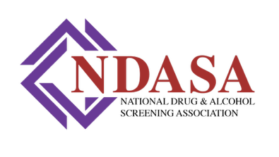
Trainer Path to Excellence Program
PROFESSIONAL LETTER OF REFERENCE

Trainee Name: Date:
Reference Name: Reference Phone Number:
Reference Company:

The above-named individual has applied to be a Trainer with the National Drug and Alcohol Screening Association. To approve his/her application, we request that you answer the following questions:
- What strengths do you believe this individual has in training?

- What style of training does this individual exhibit (visual, oral, hands-on, props, videos, power points, reading material)

- What weaknesses do you think this individual needs to improve upon?

- Have or would you have this person train for your organization? Why or why not.

If you have any questions, please do not hesitate to contact:
Kelly L Dobbins, MA, CEO, President of Mid-South Drug Testing, Inc.
NDASA Board of Directors, Secretary
kellydobbins@midsouthdrugtesting.com | 901.320.9295

