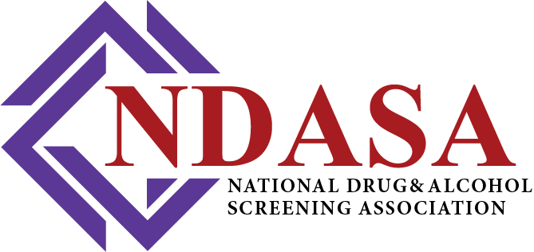

October 11, 2025
Docket No.: DOT-OST-2025-0049

Comments Submitted Via https://www.regulations.gov/ to:
Bohdan Baczara, Deputy Director
bohdan.baczara@dot.gov
Office of Drug and Alcohol Policy and Compliance
US Department of Transportation
1200 New Jersey Avenue, SE
Washington, DC 20590

Re: Notice of Proposed Rulemaking on Procedures for Transportation Workplace Drug and Alcohol Testing Programs: Addition of Fentanyl to the Department of Transportation’s Drug Testing Panel; Harmonization with Certain Items in the HHS Mandatory Guidelines for Urine and Oral Fluid; and Technical Amendments
Dear Deputy Director Baczara,
The National Drug and Alcohol Screening Association (NDASA) respectfully submits these comments in regard to the Notice of Proposed Rulemaking (NPRM), 90 Federal Register 42363 of September 2, 2025, regarding the addition of fentanyl to the U.S. DOT drug testing panel.
NDASA is a non-profit professional association representing employers and service agents who manage and support workplace drug and alcohol testing programs. Our membership represents tens of thousands of employers nationwide who are committed to maintaining safe and drug-free workplaces. NDASA’s membership includes employers, C/TPAs, collectors, BATs, STTs, laboratories, MROs, SAPs, and program administrators—all serving under the framework of the Omnibus Transportation Employee Testing Act (OTETA) and the DOT’s Part 40 procedures. As the nation’s largest trade association dedicated to this field, NDASA serves as a collaborative resource and advocate for effective policy, education, and safety initiatives that protect both workers and the traveling public.
NDASA appreciates the Department’s leadership and continued efforts to modernize the federal testing program. The addition of fentanyl to the panel is a serious and timely proposal, reflecting the urgency of addressing the national opioid crisis. While our organization supports the DOT’s commitment to public safety and recognizes the dangers fentanyl poses across our communities, we respectfully encourage the Department to consider several implementation factors before finalizing the rule, to ensure long-term program stability, cost efficiency, and scientific flexibility.
- Oral Fluid Testing Readiness and Flexibility

NDASA urges the Department to carefully evaluate whether adding fentanyl at this stage could unintentionally delay the long-anticipated rollout of oral fluid testing. Due to current FDA 510(k) clearance requirements, U.S.-based laboratories are not yet able to become HHS-certified for federal oral fluid testing, potentially forcing reliance on laboratories outside the United States.
Until the FDA considers alternative approval pathways—such as E&I (Employment and Insurance) clearance—the federal program will remain limited in its ability to adapt testing technology, modify cutoffs, or update panels and matrices as new evidence emerges. NDASA encourages the DOT to collaborate with HHS and FDA to ensure a consistent and flexible framework that enables both innovation and responsiveness in testing methods while maintaining rigorous safety standards.

- Cost Considerations and Program Balance

NDASA acknowledges and appreciates the Department’s efforts to estimate the economic impact of adding fentanyl to the panel. While our members believe that some public cost figures may be overstated, the broader issue is the need for balanced prioritization of all cost-related program components.

For instance, NDASA continues to advocate for mandatory training for Designated Employer Representatives (DERs), the individuals responsible for overseeing company compliance with DOT Part 40 programs. Historically, the Department has declined to require DER training to avoid imposing a financial burden on employers; however, the cost of quality training typically equates to less than two average DOT drug tests per company. This modest investment would substantially strengthen compliance, consistency, and safety outcomes across all transportation sectors.

As DOT evaluates the potential costs associated with expanding the testing panel, NDASA respectfully suggests that the Department also revisit the value of DER training as a complementary and cost-effective enhancement to overall program safety.

- Ongoing Collaboration and Program Support
NDASA fully supports many of the proposed technical amendments in this NPRM, including updates to definitions (§40.3), mock proficiency demonstration timelines (§§40.33, 40.35, 40.213), and revisions to collection procedures (§§40.65, 40.72, 40.73, and 40.193). These proposed changes align with best practices long recommended by our association and represent meaningful progress toward a more consistent and modernized testing program.
We remain committed to supporting the Department’s efforts and stand ready to collaborate with ODAPC and other federal partners to ensure that fentanyl’s eventual inclusion in the panel—when operational and regulatory conditions are fully aligned—can be implemented efficiently, cost-effectively, and with minimal disruption to other critical program initiatives such as oral fluid testing.
NDASA appreciates the opportunity to provide these comments and thanks the Department for its continued partnership in advancing workplace and transportation safety. We are deeply grateful for the dedication of DOT and ODAPC staff in continually improving the nation’s drug and alcohol testing programs and ensuring they remain both scientifically sound and operationally practical.

Respectfully Submitted,
M. Jo McGuire, Executive Director
National Drug & Alcohol Screening Association
1629 K Street NW, Suite 300
Washington, D.C. 20006

