
Customize your social media badge

It’s easy to add your photo! Follow these simple step-by-step instructions if you happen to be using Canva:
1. Go to https://www.canva.com/
2. If you don’t already have a Canva account, you can sign up for a free account.
3. Once you are in Canva, on the home page, click the Social Media icon and look, then the Instagram button, and then click on “Instagram Square” in the options.
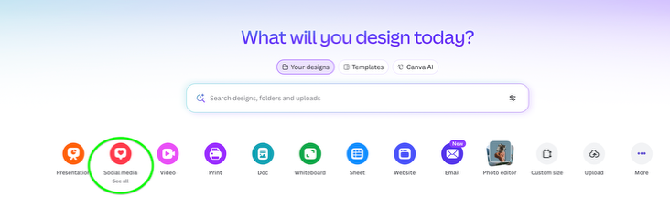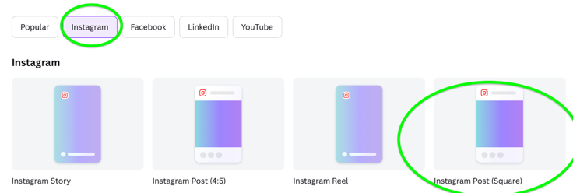

4. Then, upload your customizable photo badge, a headshot photo and maybe a logo by clicking on “Uploads” in the left-hand menu
5. Drag and drop the badge and any other media onto your canvas. Adjust the badge size to fit over the photo frame circle.
6. If you want your headshot to fit into the circle shape but it’s a square or rectangle, go to the left-hand menu, click on “Elements” and search for “frames.” Here you will find the circle photo frame. Drag and drop it to be placed on top of the existing circle frame on the badge. Then, drag and drop your photo on top of the circle photo frame.
7. Finally, click on the “Share” button in the top right-hand side of your screen to download your customized badge.
We’ll be looking out for you on Facebook, LinkedIn, Instagram, and any other social media platforms you use!

